ELECTRICAL & VIBRATORY FEEDERS POWER HARNESS

- PARTS:

QUANTITY: PART #: NOMENCLATURE: LENGTH:

1 PER CABLE (1 PER MACHINE) 19123- WIRE, YELLOW, 16 AWG 65 INCHES

1 PER CABLE (1 PER MACHINE) 19123- WIRE, YELLOW, 16 AWG 70 INCHES

1 PER CABLE (1 PER MACHINE) 19121- WIRE, RED, 16 AWG 65 INCHES

1 PER CABLE (1 PER MACHINE) 19121- WIRE, RED, 16 AWG 70 INCHES

1 PER CABLE (1 PER MACHINE) 19124- WIRE, BLUE, 16 AWG 65 INCHES

1 PER CABLE (1 PER MACHINE) 19124- WIRE, BLUE, 16 AWG 70 INCHES

1 PER CABLE (1 PER MACHINE) 46776- SLEEVE, ¼” BLACK 63 INCHES

1 PER CABLE (1 PER MACHINE) 46776- SLEEVE, ¼” BLACK 31 INCHES

1 PER CABLE (1 PER MACHINE) 46776- SLEEVE, ¼” BLACK 68 INCHES

6 PER CABLE (6 PER MACHINE) 17053- TERMINAL, SPADE N/A

1 PER CABLE (1 PER MACHINE) 17597-4 CONNECTOR, PLUG, 13-9 N/A

9 PER CABLE (9 PER MACHINE) 17598-1 CONNECTOR, SOCKET, 20DF N/A

1 PER CABLE (1 PER MACHINE) 18612-3 CLAMP, CABLE N/A

1 PER CABLE (1 PER MACHINE) 17027- CONNECTOR, 3 SKT, FEMALE N/A

3 PER CABLE (3 PER MACHINE) 17023- SOCKET, CONNECTOR N/A

1 PER CABLE (1 PER MACHINE) 19261- WIRE, WHITE, 14 AWG 33 INCHES

1 PER CABLE (1PER MACHINE) 19262- WIRE, BLACK, 14 AWG 33 INCHES

1 PER CABLE (1PER MACHINE) 19263- WIRE, GREEN, 14 AWG 33 INCHES

1 PER CABLE (1 PER MACHINE) 46777- SLEEVE, ½” BLACK 24 INCHES

- 9-PIN CONNECTOR ASSEMBLY:

- SLIDE A SET OF 65 INCH (RED, YELLOW, AND BLUE) WIRES THROUGH THE 63 INCH ¼” SLEEVING.

- SLIDE A SET OF 70 INCH (RED, YELLOW, AND BLUE) WIRES THROUGH THE 68 INCH ¼” SLEEVING.

- SLIDE A SET OF 33 INCH (WHITE, GREEN, ANDBLACK) WIRES THROUGH THE 31 INCH ¼” SLEEVING.

- STRIP 1/8” OF INSULATION FROM ONE END OF ALL OF THE WIRES.

- CRIMP AND TIN NINE CONNECTOR SOCKETS (17598-1) TO THE STRIPPED WIRE ENDS, IN ACCORDANCE WITH DIAGRAM 1.

- SLIDE THE CONNECTOR STRAIN RELIEF ONTO THE WIRES.

- INSERT THE CRIMPED WIRES INTO THE CONNECTOR IN ACCORDANCE WITH DIAGRAM 2.

NOTE 1
IT IS CRITICAL THAT THE WIRES ARE INSERTED IN THE ORDER SPECIFIED. ANY VARIATION WILL CAUSE DAMAGE TO THE CIRCUITRY.

- SLIDE THE WIRES INTO THE ½” BLACK SLEEVING.

- TWIST THE CONNECTOR STRAIN RELIEF ONTO THE CONNECTOR UNTIL HAND-TIGHT.

- TIGHTEN THE TWO PHILLIPS SCREWS TO SECURE THE CABLE TO THE STRAIN RELIEF.

- 3-PIN CONNECTOR ASSEMBLY:

- STRIP 1/8” OF INSULATION FROM THE BLACK, WHITE, AND GREEN WIRES.

- CRIMP AND TIN THE CONNECTOR SOCKETS (17023-) TO THE WIRE ENDS, IN ACCORDANCE WITH DIAGRAM 1.

- INSERT THE CRIMPED WIRES INTO THE CONNECTOR ACCORDING TO DIAGRAM 3.

- SPADE TERMINATION ASSEMBLY:

- STRIP ¼” OF INSULATION FROM THE YELLOW, BLUE, AND RED WIRES.

B. CRIMP THE SPADE TERMINALS (17053-) TO THE STRIPPED ENDS OF THE WIRES.



DIAGRAM 1

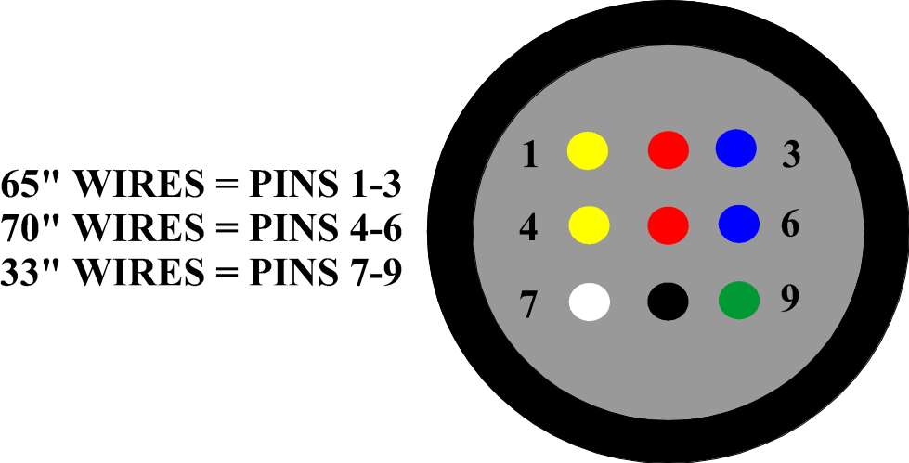

DIAGRAM 2

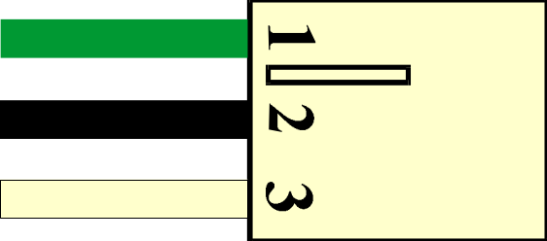

DIAGRAM 3

